

CSA0501-DATABASE MANAGEMENT SYSTEMS

LAB EXPERIMENTS DATE: 08/07/2026

EXPERIMENT 2 -- DDL Commands with Constraints – PRIMARY KEY, FOREIGN KEY, UNIQUE, CHECK

AIM:
To study and implement SQL constraints using the ALTER TABLE command by applying PRIMARY KEY, UNIQUE KEY, CHECK, and FOREIGN KEY constraints on the INTERN_EMP_INFO table.

PROCEDURE:

Open MySQL Workbench (or any SQL environment) and select the required database.

Create the INTERN_EMP_INFO and INTERN_EMP_DETAILS tables with appropriate columns.

Use the ALTER TABLE command to add a PRIMARY KEY constraint to the EmpID column.

Apply a UNIQUE constraint to the EmpName or EmpPhone column.

Apply a CHECK constraint to restrict valid values for the Performance or EmpSalary column.

Create the INTERN_EMP_DETAILS table and add a FOREIGN KEY constraint on EmpID referencing INTERN_EMP_INFO(EmpID).

Use DESC table_name; to verify that the constraints have been applied successfully.

Execute all SQL statements and observe the output.

PROGRAM:

PRIMARY KEY CONSTRAINT

CREATE TABLE INTERN_EMP_INFO
(
EmpID INT,
EmpName VARCHAR(50),
EmpDept VARCHAR(30),
EmpSalary DECIMAL(10,2),
Performance VARCHAR(20),
EmpPhone BIGINT
);
ALTER TABLE INTERN_EMP_INFO
ADD CONSTRAINT PK_EMP PRIMARY KEY (EmpID);
DESC intern_emp_info;

OUTPUT:

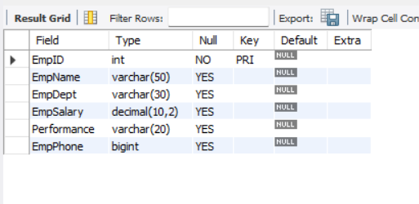
- CHECK CONSTRAINT

ALTER TABLE INTERN_EMP_INFO
ADD CONSTRAINT UQ_EMPPHONE UNIQUE (EmpPhone);

ALTER TABLE INTERN_EMP_INFO
ADD CONSTRAINT CHK_PERFORMANCE
CHECK (Performance IN ('Excellent', 'Good', 'Average', 'Poor'));
SHOW CREATE TABLE intern_emp_info

OUTPUT:

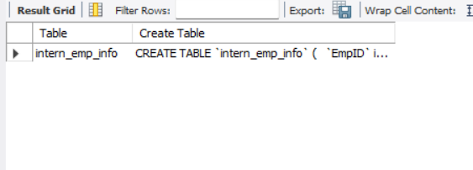
- UNIQUE CONSTRAINT:

ALTER TABLE INTERN_EMP_INFO
ADD CONSTRAINT UQ_EMPDEPT UNIQUE (EmpDept);

OUTPUT:

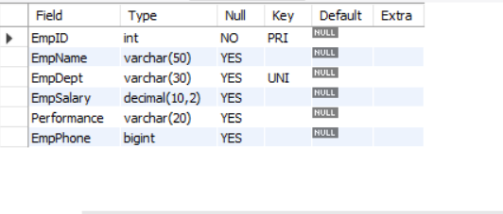
- CREATE INTERN_EMP_INFO TABLE WITH PRIMARY KEY:

CREATE TABLE INTERN_EMP_DETAILS
(
DetailID INT,
EmpID INT,
JoiningDate DATE,
Duration INT
);
DESC intern_emp_info

OUTPUT:
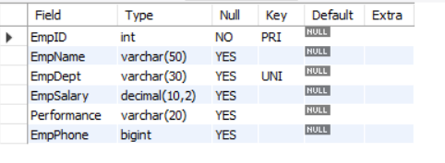

- FOREIGN KEY CONSTRAINT:

CREATE TABLE INTERN_EMP_DETAILS
(
DetailID INT,
EmpID INT,
JoiningDate DATE,
Duration INT
);

ALTER TABLE INTERN_EMP_DETAILS
ADD CONSTRAINT FK_EMP
FOREIGN KEY (EmpID)
REFERENCES INTERN_EMP_INFO(EmpID);
DESC intern_emp_DETAILS

OUTPUT:

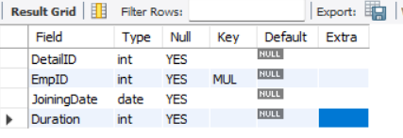

RESULT:

Thus the DDL commands with PRIMARY KEY, FOREIGN KEY, UNIQUE and CHECK constraints were successfully executed and verified in the Intern_emp_info Table.

